

Name: Muhammad Fahad

SAP ID: 37125

Section: BSCS-6A

Course: Mobile Application Development

Assignment#1

1. **Write a program to print your name in Dart.**

**Program Screenshot**

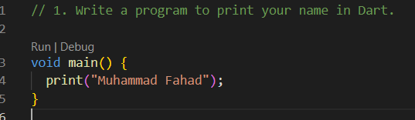

**Output Screenshot**

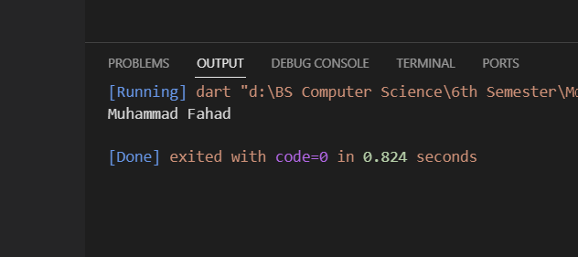

1. **Write a program to print Hello I am “John Doe” and Hello I’am “John Doe” with single and double quotes.**

**Program Screenshot**

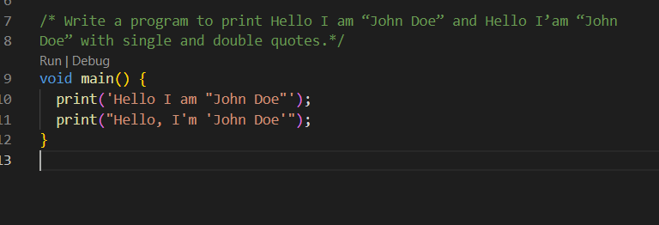

**Output Screenshot**

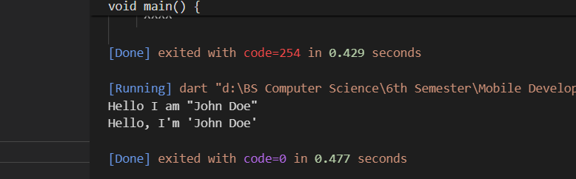

1. **Declare constant type of int set value 7.**

**Program and Output Screenshot:**

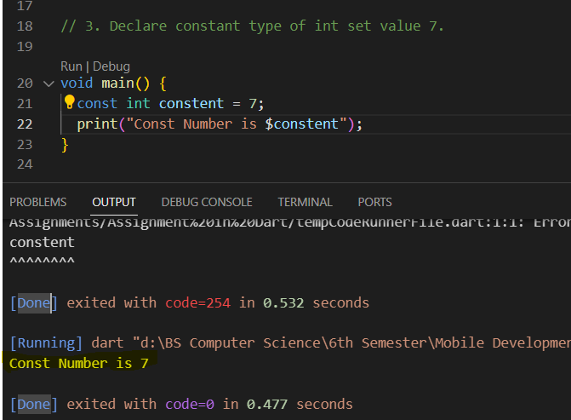

1. **Write a program in Dart that finds simple interest. Formula= (p * t * r) / 100**

**Program and Output Screenshot:**

